SALEM SMART CITY LIMITED, SALEM

APPLICATION FOR THE POST OF CEO, CFO AND CS

APPLICATION FOR THE POST OF |  |  | Affixed Photo [ should be attested by the gazetted officer]
1.Name in full (Block Letters)

2.Father’s / Husband’s Name

3.Gender  (Tick the relevant box) | Male / Female / Third Gender
4.Maritual Status  (Tick the relevant box) | Married / Unmarried
5.Full Postal Address with Mobile No. & email-id
a) Permanent Address:

--------------------------------------------------------------------------------

--------------------------------------------------------------------------------

--------------------------------------------------------------------------------

Pincode:

District: Mobile No: email-id:
b) Address for correspondence

--------------------------------------------------------------------------------

--------------------------------------------------------------------------------

--------------------------------------------------------------------------------

Pincode:

District: Mobile No: email-id:
6.Nationality : |  | Religion :
7. a) Date of Birth :  D D / M M / Y Y Y Y  (Self attested copy of High School Certificate showing Date of Birth must be enclosed) |  | b) Age :
8.a) Mother tongue :
(Please mentioned if Tamil is not mother tongue)

b) Second Language in School :

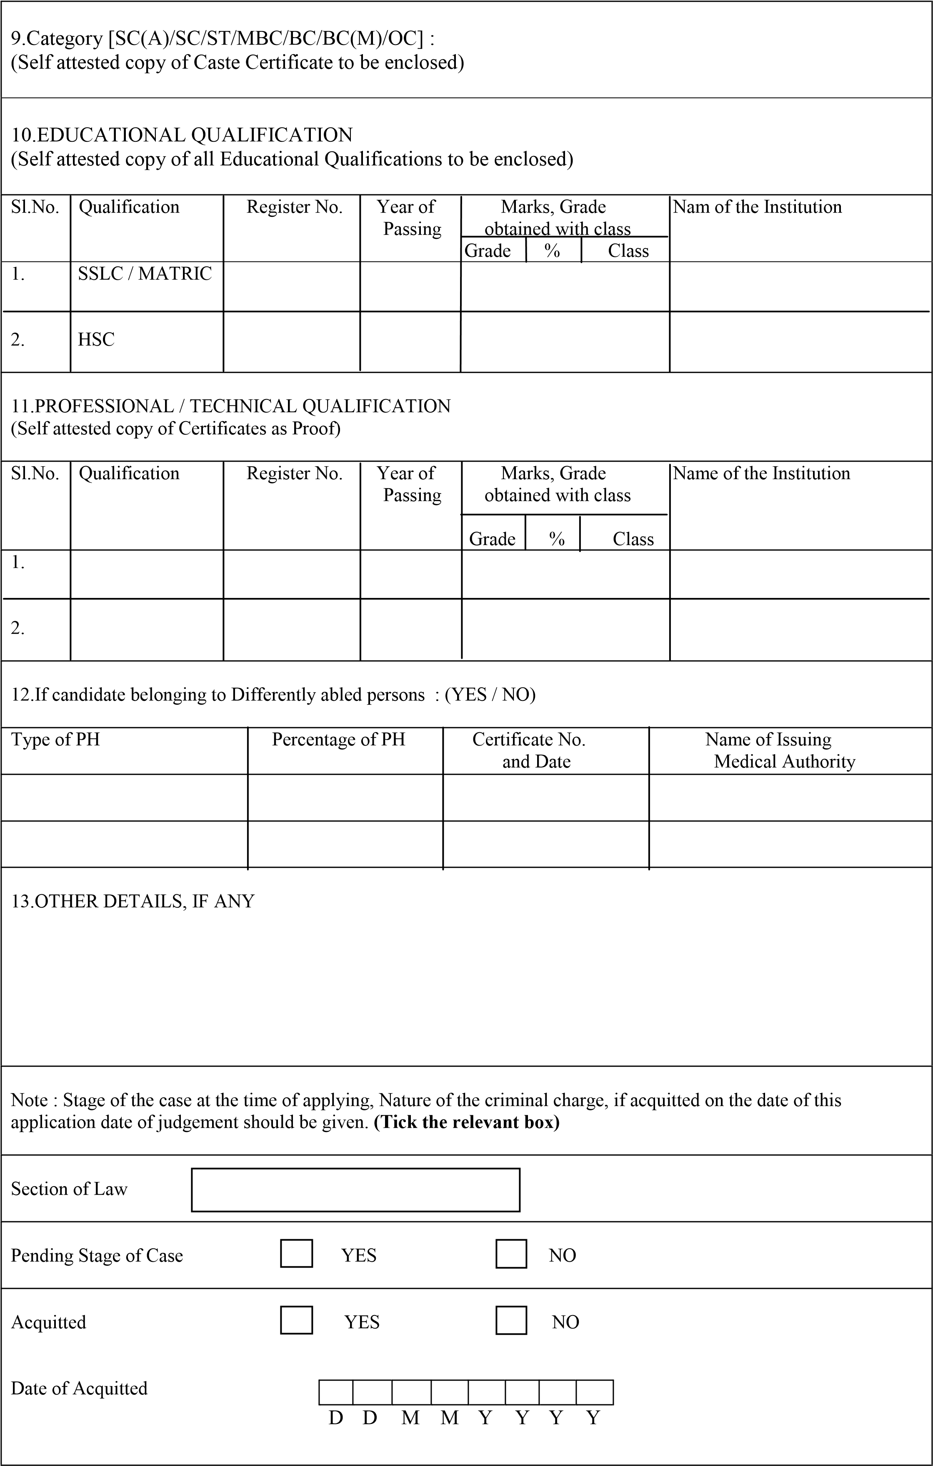

PARTICIPATION IN POLITICAL

In agitation YES NO

As member of Political YES NO
Organisation

Candidate in Election YES NO

Enclosures (Tick the relevant Column) to be attached

Sl.No. | Documents | Yes | No | Not applicable
1. | Passport size photos (Colour) 1
2. | Date of Birth (SSLC / Matric passed Certificates)
3. | Educational Qualifications 10th  (Certificates &Marksheets)  HSC  Degree
4. | Community Certificate  [SC(A)/SC/ST/MBC/BC/BC(M)/OC] – in prescribed proforma
5. | No Objection Certificate (in case of Departmental candidates)
6. | Differently abled persons Certificate in prescribed proforma for Employment in State Government
7. | Discharge Certificate (in case of Ex-servicemen)
8. | Whether all above documents / certificates are self attested

Signature of the Candidate

DECLARATION

I hereby declare that all the statements made in this application are true and correct to the best of my knowledge and belief. In the event of any information being found false / incorrect or ineligibility deducted before or after the written test / certificate verification or even after appointment, my candidature / appointment will stand automatically cancelled.

Signature of the Candidate

